How To for Students:
Home Learning with Seesaw

Follow these steps or watch a video
 | STEP 1: Download or update the Seesaw Class app on your device or go to app.seesaw.me to get started. App update is required!
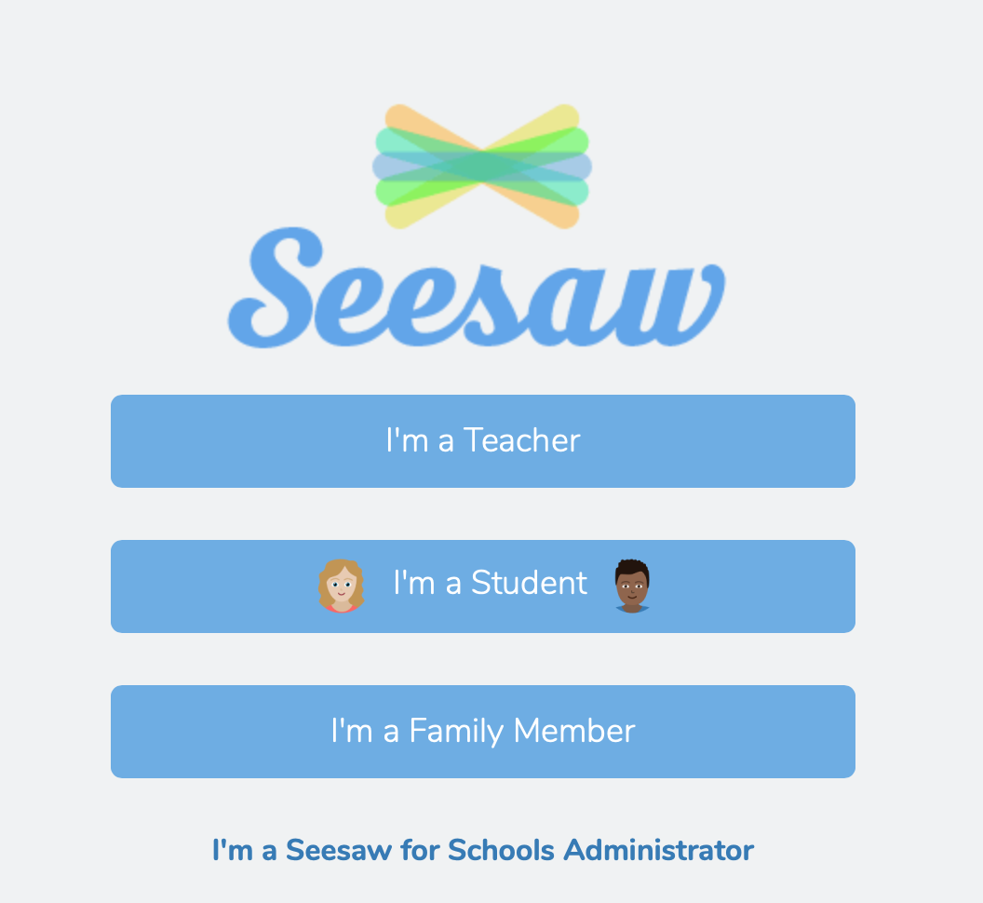 | STEP 2: Click ‘I’m a Student’ to log in with your Home Learning Code.
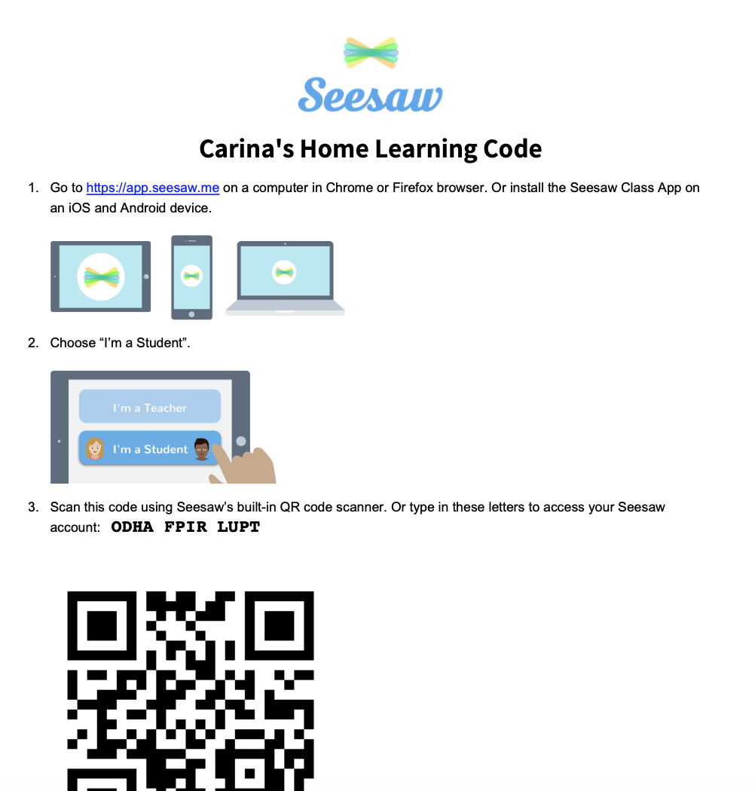 | NOTE: Your teacher may have sent your Home Learning Code on a handout like this or in an email or text message.
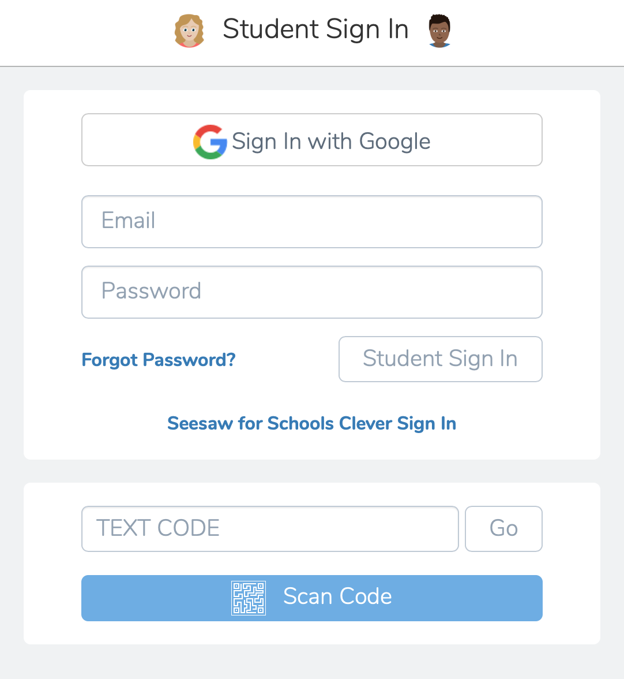 | STEP 3: Enter your Home Learning Text Code or scan your Home Learning QR Code when you see this page.
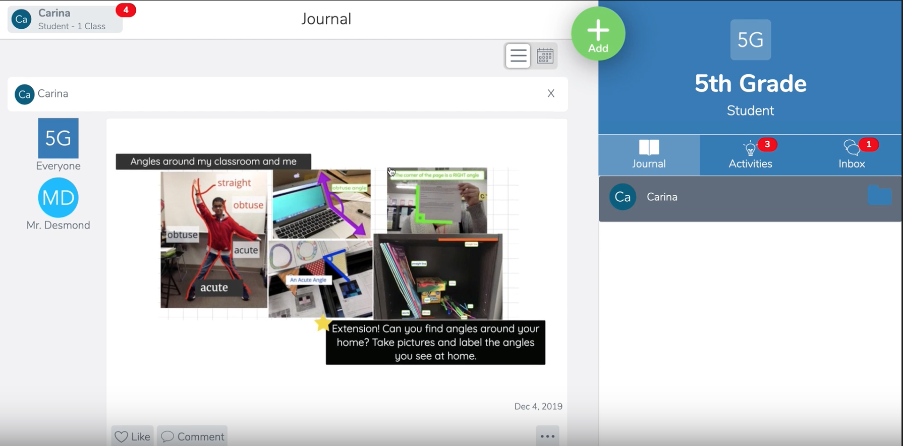 | STEP 4: Once logged in, you will be in your student journal where you can create posts, complete activities, and see Announcements from your teacher.
 | STEP 5: To see activities from your teacher, tap the Activities tab (on the right side under class name).
 | STEP 6: Click ‘Add Response’ to respond.
 | STEP 7: Always press the green check to save work to your journal.
 | STEP 8: To see Announcements from your teacher, tap the inbox tab (on the right side under class name)

